MULT 25-604 – Aerial Precision: 3D Reality Capture and GIS Integration with Drone Technology

**Project Proposal**

Prepared for

Matt Merrill

GeoDecisions

By

Adil Adil

Grady Beck

Colin Drake

Nathan Germain

Under the supervision of

Tamer Nadeem and Yuichi Motai

October 11, 2024

**Executive Summary**

This document provides a definition of the scope, work, and deliverables for the Aerial Precision project sponsored by GeoDecisions and commissioned by Virginia Commonwealth University to use photogrammetry and LiDAR data to create a viewable map product that may be used by the company to make informed decisions and aid in the development process. Herein are the methods by which the project shall be completed and the limitations that have so far been identified that may limit the design process, and the alternatives that may be used to circumvent those constraints. The problem statement gives a detailed look at the process as a whole and some background information that will be helpful to understand the project and the overall process that will be taken to fulfill the project requirements. The problem statement provides a detailed overview of the project, including background information necessary to understand the project’s goals and the process to meet its requirements. The following section presents the design requirements, including the goals and objectives, and then identifies specifications and constraints that will help narrow the feasible design options. Relevant codes and standards crucial to the project's execution are also detailed.The document then defines the scope of work throughout the project lifecycle, outlining the deliverables that will be provided to the sponsor, key milestones to ensure the project stays on schedule, and the resources needed to meet these deliverables. These resources may need to be acquired or purchased during the project timeline. Overall, this document is a jumping off point to provide to the sponsor a clear definition of what is intended by the project team and what may be expected as the project progresses.

**Table of Contents**

Section A. Problem Statement

Section B. Engineering Design Requirements

B.1 Project Goals (i.e. Client Needs)

B.2 Design Objectives

B.3 Design Specifications and Constraints

B.4 Codes and Standards

Section C. Scope of Work

C.1 Deliverables

C.2 Milestones

C.3 Resources

Appendix 1: Project Timeline

Appendix 2: Team Contract (i.e. Team Organization)

References

### Section A. Problem Statement

In order to make the most educated decisions about infrastructure projects, visualization of the structure and its spatial data are crucial. Visualization is needed in consulting and design analysis to provide customers with a visual representation of the actual structure in the field and to make the most informed decisions based on the most up to date information. GeoDecisions, a division of Gannett Fleming focused on delivering geospatial technology and data to its customers, has sponsored this project through Virginia Commonwealth University to design and prepare a process to use drone technology to make three dimensional models of worksites in order to fulfill this mission.

While many tools exist already to do much of the photogrammetric and geospatial processing, the project sponsor seeks a way to bring all of these tools together into a streamlined, efficient, and replicable process that spans from collecting the raw data in the field using LiDar and geolocation-embedded aerial imagery to processing it through a GIS system and then displaying that data through the chosen set of tools in an easily deployable and accessible online platform. This may then be used either within the company as a way to analyze projects and sites or as a way to provide information and insight to its clients. This project seeks to streamline this process and provide the most efficient means of taking it from the data collection stage to the data display stage. As GeoDecisions is an ESRI Partner, the incorporation of the ESRI software suite in as much of the design process as possible is a major focus in order to expand the capability of the tools that are already available and preferred by the company [5].

The first portion of the project will be dedicated to determining the appropriate hardware for use with the project. This will include determining which type of drone, sensors, and other materials will be needed in order to collect the appropriate type and amount of data needed for successful runs of the process being designed. This includes both photogrammetry and LiDar data, both of which will be assessed for their benefits and drawbacks as well as for the method by which the data is formatted, processed, and visualized in the context of a GIS system. LiDar data has already been used in the planning, maintenance and design of projects across many industries including surveying, construction, and highway development [3]. Photogrammetry shares many of these use cases and also contributes a greater ability for creating maps due to its photorealism and color [4].

The next stage of the project will then take the data collected and determine the best way to preprocess the data before it is imported into the GIS software suite. This will include the extraction of the data from the chosen hardware and ensuring it is in the appropriate format before importing it into the next stage, which will be the integration of the data with the ESRI suite. This will include learning and researching the capabilities of ESRI’s products, specifically the ArcGIS line of products including ArcGIS Pro and ArcGIS Online, as well as some of the extensions and geoprocessing tools that may assist in the execution of the project goals. Alternatives for these software components exist, including QGIS as an open source GIS software and other paid tools that run cloud-based photogrammetry, but because all of this software is already in use by the client and accessible to them, the ESRI suite will be the best option for the deployment of this project [1]. It also provides all tools within one suite, whereas two or three may be required from different developers if using an alternative that would likely make the project less cohesive and more complicated. This will be a major component of the work and will lead into the next stage, creating a view of the data for the end user.

Creating ways to visualize the collected data in an easy to understand and useful manner will be the component of the project most visible to the end user. Many possibilities for displaying the data exist, but in order to stay within the ESRI software system at the request of the sponsor and it already being integrated with the software being used for the processing stage, ArcGIS Online will be the target platform for creating a viewer for the data. Other alternatives would have included creating a custom web-interface likely with server functionality, which would have exceeded the scope and purpose of the project and would have been too lengthy to do in contrast to what is already available through ESRI. Another would be using another proprietary alternative such as GeoSolutions MapStore, but would have run into similar complications with compatibility and would cost more money than using what is already available to us [2].

Once the process from drone data to a viewer is complete, the project will move to document the best methods developed during the prototyping stage in order to provide a technical plan of operation (TPO) to the sponsor to create replicable results that can be applied in the day to day operations of GeoDecisions. After creating the plan of operation sample data that has been processed and put into a viewer will be provided as well to aid in the proof of concept and provide anyone seeking to replicate the results with the same data to test the system with.

While many companies face the challenge of learning how to use and integrate this new technology into their workflow, GeoDecisions is seeking to better utilize the tools already at their disposal to incorporate the visualization from data retrieved through drone technology into their offerings to their customers and in their own decision making process. By completing this important work, the project will deliver a streamlined process that makes the development of this type of insight more accessible to the company and will allow them to offer drone data comparable to and competitive with others in the geotechnical industry to place them at the leading edge of consistent drone integration into geospatial projects.

### Section B. Engineering Design Requirements

The design requirements for this project focus on creating a drone-based system capable of collecting photogrammetry and LiDAR data, processing it into 3D models, and displaying it via a web-accessible interface, such as ArcGIS Online. Key constraints include the drone's ability to carry the necessary sensors, processing data into compatible formats like .las and DEM, and integrating with existing hardware within the sponsor’s budget. The workflow must be optimized for efficiency and thoroughly documented to ensure replicability, all while adhering to federal, state, and local regulations.

#### B.1 Project Goals (i.e. Client Needs)

This project aims to produce an efficient, repeatable workflow for producing detailed 3D models of structures and worksites and making them available in a web interface. The completed workflow will integrate with existing tools that the sponsor prefers, with data collection performed by an aerial drone with sensors for photogrammetry, LiDAR, or both. Documentation is a key component of the final project, as it will allow the sponsor to reproduce results at sites beyond the sites flown in support of the design and development of the initial models.

* Design and implement a drone-based system for collecting photogrammetry data, and explore options for integrating LiDAR data into the system.
* Determine optimal processing workflow to translate collected data into 3D models within a web-accessible environment.
* Produce the completed model in a geolocated virtual environment, along with a functional interface for viewing and interacting with the model.
* A Technical Plan of Operations, or the documentation of how to run the workflow
* Provide a framework, or exploration of the possibility, of additional computer vision or machine learning enhancements on top of the processing framework or interface.

#### B.2 Design Objectives

Based on the project goals, the completed design must achieve a number of clear, measurable objectives. Among these are the physical objectives of the drone system and any integrated sensors, as well as the process objectives that will detail the workflow of how the system operates. The major objectives of this project are listed below:

* The drone will carry the necessary payload to collect GPS, photo, LiDAR, and kinematics data.
* The drone and payload will be specified within the budget of the sponsor, or use existing hardware in order to stay within budget and provide requested functionality.
* The workflow will be developed within an industry-standard application, and be optimized to the extent possible in order to reduce flight and processing time.
* The documentation will be specific and detailed, providing all steps necessary to recreate the results of the original collection run(s) and subsequent model(s) from this project.

#### B.3 Design Specifications and Constraints

In order for the proposed data collection system and documentation to meet the objectives above, there are a number of considerations that need to be accounted for, especially considering the need for the completed project to integrate with an existing digital environment. Chief among these specifications and constraints are the *Functional constraints*, like the ability to collect sponsor-specified data and complete the processing in a timely manner, the *Cost and Manufacturing constraints*, like part or sensor availability, and the *Data and Interoperability constraints*, like ensuring the system can be structured within existing tools or frameworks.

* The design must be able to carry sensor payload (camera and/or LiDAR unit) along with any onboard data storage/processing needed for a minimum of 20 minutes (*Functional*)
* Data collected must include geolocation information (GPS) in order to properly encode photo and/or LiDAR data (*Data*)
* Data must be processable into .las file types (LiDAR) or digital elevation models (DEMs) of either digital surface model or digital terrain model (DSM, DTM) type (*Data*)
* Design must integrate or accept input from the existing drone as specified by the sponsor [DJI Mavic Air] (*Functional, Interoperability*)
* Documentation should be complete to the point that no further resources are required (aside from hardware) to reproduce results at different sites (*Functional, Maintenance*)
* Design must not interfere with other aircraft, radio signals, and their reception/transmission, and any law enforcement or emergency services, per Federal Aviation Administration, Federal Communications Commission, and Virginia State codes and regulations (*Functional*)

#### B.4 Codes and Standards

FAA Part 107:

Sets standards and establishes guidance regarding FAA Remote Pilot Certification, operational limitations, and airspace restrictions.

Virginia Code § 15.2-926.3 (Local Government Regulations):

Local governments in Virginia are allowed to regulate drone use in specific areas. Therefore, if you are flying in a certain city or county, check the local ordinances for any additional restrictions.

### Section C. Scope of Work

This project will develop a streamlined process for collecting, processing, and visualizing drone-based photogrammetry and LiDAR data to enhance decision-making for infrastructure projects. The scope of work includes identifying the appropriate drone hardware and sensors, collecting and preprocessing the data, and integrating it with the ESRI ArcGIS suite for geospatial analysis. The final stage will focus on building an accessible ArcGIS Online viewer for stakeholders to visualize and analyze 3D models of work sites. Deliverables include a technical plan of operation and a proof-of-concept dataset for replicable use, along with the Capstone-specific items like the abstract, project posters, and formal report.

#### C.1 Deliverables

The following deliverables will be provided to ensure a comprehensive and replicable process for the drone-based mapping system, from data collection to visualization, along with supporting documentation and a representative dataset. Although the majority of the deliverables are determined by the sponsor, there are also posters, abstracts, and project reports that all Capstone projects must include. These deliverables will serve as key outputs of the project to facilitate future use and analysis by the sponsor.

* Technical Plan of Operation (TPO): Detailed process for replicating data collection, processing, and visualization, including implementation of the modeling process from start to finish.
* ArcGIS Online Viewer Template: Example setup for displaying 3D models of collected data.
* Sample Data: Data set used for testing and replicating the modeling process.
* Code and Tools: Any custom code or tools developed during the data optimization and workflow process.
* Completed Data Collection Run(s): Collected and processed data displayed in a web portal.
* Final Project Report: Comprehensive report summarizing the project’s methodology and results.
* Posters, Flyers, and Presentation Materials: Visual materials for project dissemination.
* Project Proposal and Timeline: Initial project scope and timeline for execution.
* Bi-weekly Updates and Weekly Status Reports: Regular updates to track project progress.

#### C.2 Milestones

The project can be broken down into a number of milestones that correspond to both project objectives and deliverable deadlines. Each milestone builds off the progress of the previous ones, and the timeline established (Appendix 1) should be reflective of the overall pace of the project, despite being an informed projection and not a strict schedule. Any changes to the project scope, deliverables, and milestones should be thoroughly discussed and mutually agreed upon by all parties, and documented and justified in detail.

* Startup/Kickoff: Make introductions as a full team to establish the *team contract*, general meeting schedule, and rough scope of project.
* Initial Research: Meet with sponsors and determine the needs, wants, and expectations of the finished design. Begin researching in order to specify the project and create a *project proposal*.
* Design I: Select sensors, drones, and other hardware. Gain access to ESRI suite and begin determining what tools will be needed to process data.
* Design II: With sample dataset, display projection of real-world geometry in ArcGIS, begin web portal access research
* Design III: Develop interim workflow based on results of sample data processing, and *finalize design* for data acquisition system.
* Design Documentation: Provide finalized documentation of the design, and detail completed work on the *Fall design poster*.
* Design Reporting: Document the final project design in a formal report as a guideline for implementation during the Spring semester.
* Pre-Implementation: Finalize data collection and preprocessing workflows as needed, and perform setup of digital tools and environment for data collection.
* Implementation I: Determine test location, develop flight plan and best practices, refine limitations and guides for location survey in general.
* Implementation II: Perform test flight, collect results, and verify data entered into ESRI ArcGIS tools behaves as expected for pre-processing. Further, refine pre-flight workflow.
* Implementation III: Derive 3D models from processed flight data based on established design, and place models in a representative virtual environment.
* Final Implementation: Provide *web portal access* to the model in a user interface, allowing time for layout and function refinements.
* Finalized Documentation: Taking into account previous notes and revisions, produce a *technical plan of operation* that details the process from hardware selection to environment viewing.
* Presentation of Results: Produce and display the *project abstract* and *final poster*, and present them to peers and stakeholders for evaluation.

#### C.3 Resources

Resources for the project will be provided almost entirely by the project sponsor, GeoDecisions, as they are the primary stakeholders. We will specify a variety of hardware and software requirements that we expect to work best in this application. However, the final decision of what equipment to use is based on company resources, preferred systems, and familiarity. Expected resources include:

* ESRI ArcGIS Suite - Data processing and visualization tool for GIS data.
* A Drone with high definition camera, and the ability to integrate further sensors (LiDAR).
* Computer resources for data processing, flight planning, and other data tasks.
* IDE for software development, including Python and necessary dependencies.
* Virtual environment for building models and implementing processing code.
* Any data provided by the sponsor that can be used to implement into ArcGIS.
* A LiDAR sensor is to be integrated into the drone and be used in the implementation phase.

ESRI ArcGIS suite is being provided as the core tool for our implementation of the project. It will be used to convert and link the data from the drone and LiDAR sensors into photogrammetry data. This tool was chosen because it is easily accessible, and is used by GeoDecisions, which will provide us with a license to use the software. For our drone on the other hand, we are given a drone from GeoDecisions mentioned previously; however, we are recommending the use of DJI Matrice 300 RTK for its various features and easy integration software into ArcGIS. Another possibility would be the DJI Mavic 3 Enterprise, which is similarly designed with a high-spec camera and the ability to expand function with other payloads. The drones, while both excellent choices for a full-featured drone mapping system, are priced outside of the budget range, and since we are given a drone to use already, we could use the funding to choose a better LiDAR sensor.

A good LiDAR sensor that can be used for our case and is within our budget is YDLIDAR G4. It is a friendly, easy to use, sensor that offers 360-degree scanning with a range of 16 meters. Priced around 300$, this LiDAR sensor is a good fit for our use. It is unknown still if GeoDecisions is going to provide us with a sensor; however, in the case they don’t YDLIDAR G4 is the choice of use. If greater ranges were needed, and appropriate funding was available, a more robust product like the Ouster Velodyne VLP16 could provide a greater scanning area and fidelity. As for an IDE, it is recommended that we use a universal IDE that can be accessible to anyone who is trying to replicate the process. For example, VScode is a great example of a universal IDE.

### Appendix 1: Project Timeline

Here’s a Gantt chart that outlines a rough timeline for the project. This Gantt chart can be subject to change depending on the design and implementation of the project. It specifies over which period of time each phase of the project should be completed and ensures that the project is progressing as it should over its duration. This is meant to keep the team on track and to give a rough estimate of when certain tasks should be completed to be on track with submitting the project and deliverables in an appropriate time frame.

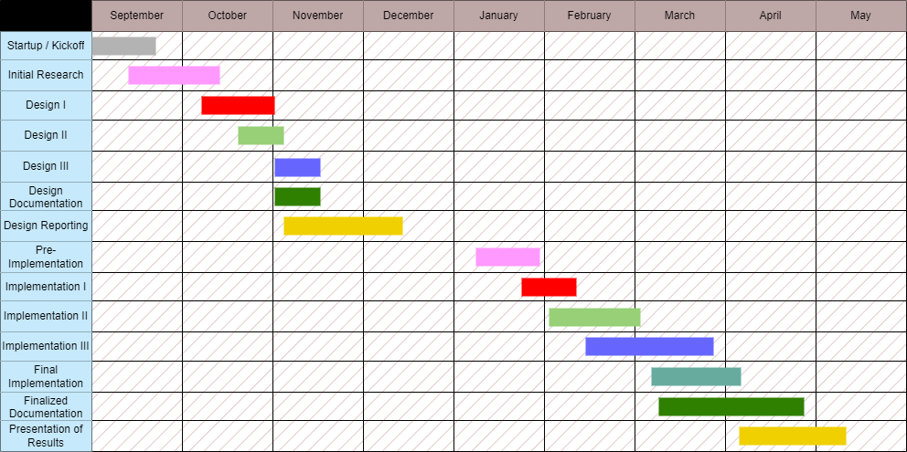

### Appendix 2: Team Contract (i.e. Team Organization)



MULT 25-604 – Aerial Precision: 3D Reality Capture and GIS Integration with Drone Technology

**Team Contract**

Prepared for

Matt Merrill

GeoDecisions

By

Adil Adil

Grady Beck

Colin Drake

Nathan Germain

September 4, 2024

Contents

Step 1: Get to Know One Another 2

Step 2: Team Culture. Clarify the Group’s Purpose and Culture Goals. 3

Step 3: Time Commitments, Meeting Structure, and Communication 4

Step 4: Determine Individual Roles and Responsibilities 5

[Step 5: Agree to the above team contract 6](https://docs.google.com/document/d/1iB8jfZwFbzOrGAgHc2QS5s-RtAHBWuWo/edit#heading=h.1t3h5sf)

# Step 1: Get to Know One Another. Gather Basic Information.

| ***Team Member Name*** | ***Strengths each member bring to the group*** | ***Other Info*** | ***Contact Info*** |
| --- | --- | --- | --- |
| Adil Adil | Circuit Design, Programming, Problem Solving, Time Management, Work Ethics, Leadership, Task Allocation, Drone Experience | VCU Makerspace Certified, FSAE Experience | adila2@vcu.edu |
| Grady Beck | Programming, Drone Experience, GIS Experience (ArcGIS), Time and Resource Management, Work Ethic, Communication | Computer Science Student | beckgm@vcu.edu |
| Colin Drake | Communication, project management, results-driven, prototyping, programming | VCU Makerspace Certified | cdrake3@vcu.edu |
| Nathan Germain | Problem-solving  Some experience in FPGAs and embedded design, Logistics | VCU Makerspace Certified | germainnt@vcu.edu |

| ***Other Stakeholders*** | ***Notes*** | ***Contact Info*** |
| --- | --- | --- |
| *Faculty Advisors*  (Yuichi Motai, Tamer Nadeem) | Dr. Motai is the ECE advisor.  Dr. Nadeem is the CS advisor. | ymotai@vcu.edu  tnadeem@vcu.edu |
| *GeoDecisions*  (Matt Merrill) | Senior Technical Solutions Director | mmerrill@geodecisions.com |

# Step 2: Team Culture. Clarify the Group’s Purpose and Culture Goals.

| ***Culture Goals*** | ***Actions*** | ***Warning Signs*** |
| --- | --- | --- |
| Openness about deadlines and objectives | - Be transparent about progress, especially if deadlines are close  - Be willing to schedule time for critical tasks, even when inconvenient | - Team members do not respond to requests for progress updates  - Vague scheduling conflicts without reason/justification |
| Responsive communication and professional decorum | - Requests for input and scheduling are replied to in a timely manner  - Team members assume positive intent, and constructively address interpersonal issues | - Team member provides deliverables with little time to integrate and bug check  - Not replying to group messages within a reasonable time |
| Collaborative engagement | - Divide and delegate tasks fairly, let each other work to our strengths  - Help one another where applicable, and make an effort to understand the work of others | - Hogging drone flying time  - Regularly delegating work to others without producing personal results |
| Informal gathering and teambuilding | - Find time to meet where project work isn’t the priority  - Engage in common interests, study other classes, gripe about work, etc. | - Repeatedly finding excuses to avoid informal gatherings |
| Standards and uniformity | - Documentation and communication are to be formatted in a standard fashion to promote professionalism | - Comic Sans  - Arial |

# 

# Step 3: Time Commitments, Meeting Structure, and Communication

| ***Meeting Participants*** | ***Frequency***  ***Dates and Times / Locations*** | ***Meeting Goals***  ***Responsible Party*** |
| --- | --- | --- |
| Students Only | As Needed, On Discord Voice Channel | Update group on day-to-day challenges and accomplishments |
| Students Only | Every Wednesday Evening, on Discord and every Monday in person after faculty update meeting (below) | Actively work on the project and update any documentation we have or need (everyone participates) |
| Students + Faculty advisors | Will meet on Monday at 3:30pm in ERB 2308 | Update the faculty advisors and get more information about certain aspects of the project. |
| Project Sponsor | Once a Month, Either over Zoom or in person | Determining Project expectations and goals, requirements, and feedback. Each team member is responsible for being present for meeting |

# Step 4: Determine Individual Roles and Responsibilities

| ***Team Member*** | ***Role(s)*** | ***Responsibilities*** |
| --- | --- | --- |
| Adil Adil | Systems/Mfg Engineer | * Leads design and fabrication process. * Test any Hardware manufactured. |
| Grady Beck | Financial Manager | * Budgets project funds and handles financial records. * Encourages responsible use of funds and materials. |
| Colin Drake | Project Manager | * Develops schedule and project agenda. * Maintains and promotes a positive environment within the group. * Provides point of contact to outside parties as needed. |
| Nathan Germain | Logistics Manager | * Coordinates use of reserved space, and storage space. * Collaborate with the team and faculty to allocate resources and plan events. |

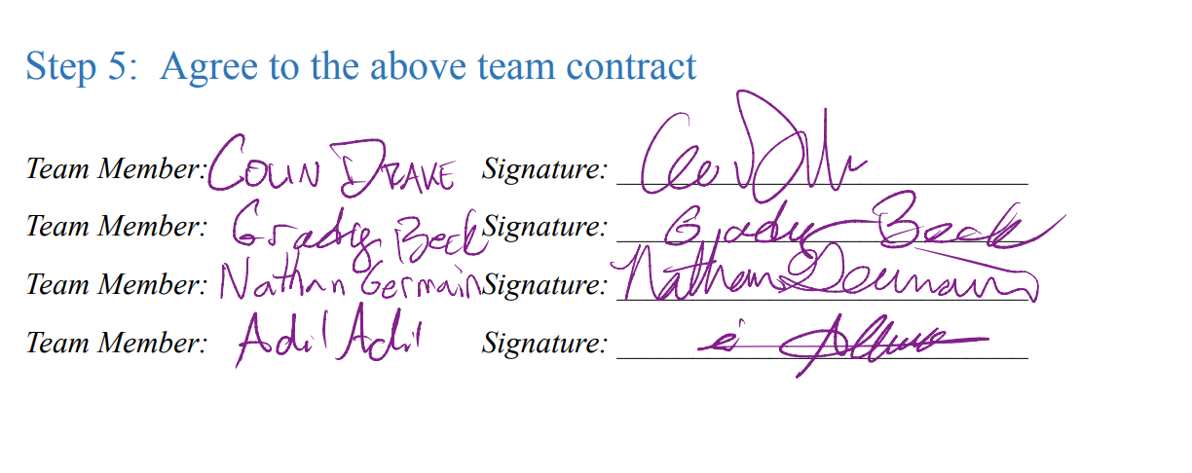

### References

[1] University of Pennsylvania. "GIS Resources: Geographic Information Systems (GIS)." Penn Libraries. Accessed September 29, 2024.<https://guides.library.upenn.edu/c.php?g=475370&p=3254298>.

[2] GeoSolutions Group. "MapStore Technologies." Accessed September 29, 2024.<https://www.geosolutionsgroup.com/technologies/mapstore/>.

[3] FlyGuys. "5 Industry Use Cases for LiDAR." Accessed September 29, 2024.<https://flyguys.com/5-industry-use-cases-for-lidar/>.

[4] PIX4D. "Five Industries That Use Photogrammetry." Accessed September 29, 2024.<https://www.pix4d.com/blog/five-industries-that-use-photogrammetry/>.

[5] Esri. "GeoDecisions." Accessed September 29, 2024.<https://www.esri.com/partners/geodecisions-a2T70000000TNRDEA4>.